**Task 11**

@Trainee your task for docker is to

* Pull an image of mysql

Pull an image from a Docker Hub

docker pull

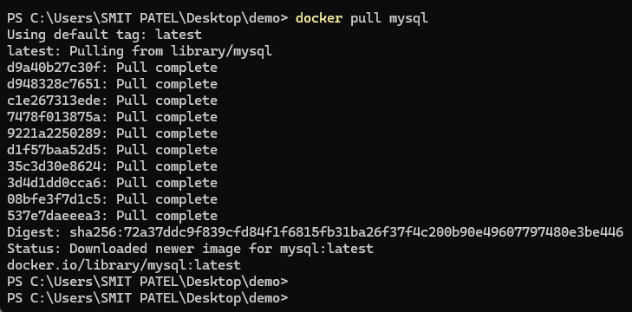



* Make a container from it with the name

[YOUR_NAME]-mysql

* When making a container, expose its port for connection (check its page for details) to your local machines port 9306
* The container should have a root password of your choice, a DB named

[YOUR_NAME]DB

and a account that can access this database

Runs the container in detached mode (-d).

Names the container smitpatelmysql.

Sets the root password to smitDB.

Creates a database named smitDATA.

Creates a user smit with the password smitDB.

Maps the container's MySQL port 3306 to your local machine's port 9306.

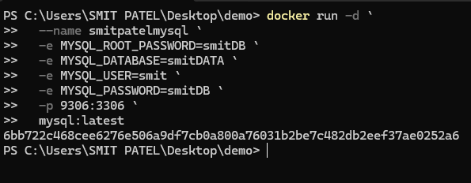



* To test the connection, use any technology, MySQL Workbench, React, SpringBoot, Vanilla JS, PHP, etc. to connect to this DB using the account created

const express = require('express');

const mysql = require('mysql2');

const cors = require('cors');

const app = express();

const port = 3001;

app.use(cors());

app.use(express.json());

// Create connection to MySQL database

const db = mysql.createConnection({

  host: '127.0.0.1',

  port: 9306,

  user: 'smit',

  password: 'smitDB',

  database: 'smitDATA'

});

// Connect to MySQL database

db.connect(err => {

  if (err) {

    console.error('Error connecting to the database:', err);

    return;

  }

  console.log('Connected to the MySQL database.');

});

// Simple API endpoint to get users

app.get('/users', (req, res) => {

  db.query('SELECT * FROM users', (err, results) => {

    if (err) {

      res.status(500).send(err);

    } else {

      res.json(results);

    }

  });

});

app.listen(port, () => {

  console.log(`Server running at http://localhost:${port}`);

});

